**Assignment 2 – Amirthavarshini**

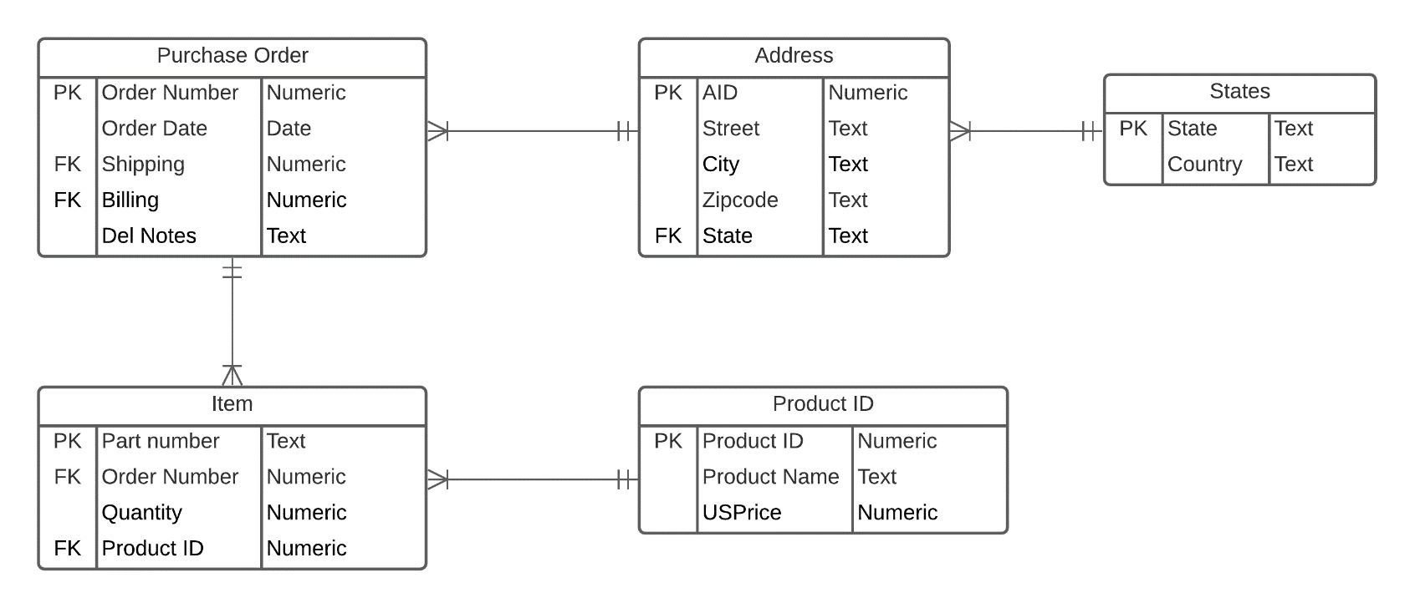

**Assumptions:**

* In the table States, state is unique i.e. no country will have two states with same name and no countries will have states with same name as the other country.
* Zip code doesn’t uniquely identify city and street. Eg. Boston is a city and has zip code 02215, 02120 etc. among many others. Similarly street cannot have unique zip code as multiple streets can come under same zip code.
* Street is not functionally dependent on zip code. Eg: St Alphonsus St in Michigan has different zip code and St Alphonsus St in Boston has different zip code.
* Product ID uniquely identifies each product.
* Same Product by different sellers will have different Product ID and different price.
* Every product in the Item table will have a unique Part number.
* Product can be ordered in multiple quantities.

**Multiplicities:**

* **Purchase Order and Address(Many to One):** 
  + - Each purchase order will have one address to which the product needs to be delivered but the address can appear in multiple purchase orders i.e. you can have multiple products belonging to different purchases coming to the same address.
* **Address and States(Many to One):**
  + - Each address can have only one state in it but a state can appear in multiple address
* **Purchase Order and Items(One to Many):**
  + - A purchase order can have one or more items but an item can belong to only one purchase order.
* **Items and Product ID(Many to One):**
  + - Each Item will have one instance of product but one or more instance of product can appear in Items.

**Proof that the table is in 3NF:**

The functional dependencies for the above table is as shown below**:**

**1. Purchase Order:**

Order number -> Order date

Order number -> del notes

Order number -> Shipping

Order number -> Billing

1. **Address:**

AID -> Street

AID -> City

AID -> Zip code

AID -> State

1. **States:**

State -> Country

1. **Item:**

Part number -> Quantity

Part number -> Order number

Part number -> Product ID

1. **Product ID:**

Product ID -> Product name

Product ID -> USPrice

The tables are in 3rd Normal Form because the tables are in second normal form and there doesn’t exist any transitive dependencies among the attributes.